Error: Reference source not found

Los Angeles Child Guidance Clinic
Employment Opportunities Online Application System

Team 5

Zhen Huang – Builder, Tester
Ruixin Huang – Feasibility Analyst, Builder
Hao Cai – Prototyper, Project Manager, Builder
Chan Li – Life Cycle Planner, Tester
Shipeng Xu – Software Architect, Builder
Cresta Kirkwood – IIV&V, Requirements Engineer

04/27/2012

Version History
Date | Author | Version | Changes made | Rationale
10/06/11 | Hao Cai | 1.0 | - Document was created. Section 1, 2, 3.2, 3.4were completed | - Core PC Package
10/06/11 | Chan Li | 1.1 | - Section 3.3.1 was completed | - Core PC Package
10/07/11 | Hao Cai | 1.2 | - Section 3.1, 3.3.2 were completed | - Core PC Package
10/09/11 | Hao Cai | 1.3 | - Some bugs have been fixed | - Bugzilla
10/12/11 | Hao Cai | 1.4 | - Some bugs have been fixed | - Bugzilla
10/13/11 | Hao Cai | 1.5 | - Modified business workflow, stakeholders table, system boundary and environment, relation to current system table and organizational and operational Implications | - Deeper understanding on requirement  - Draft PC Package
10/21/11 | Hao Cai | 2.0 | - Modified the System Boundary and Environment, Element Relationship Diagram and Benefit Chain Diagram | - ARB
11/15/11 | Hao Cai | 3.0 | - Modified the benefit chain diagram, element boundary diagram, current business workflow and business workflow | - TA Grades of the Foundations Commitment Package
02/06/12 | Hao Cai | 4.0 | - Modified the element boundary and Infrastructure | - Draft RDC Package
02//15/12 | Hao Cai | 4.1 |  | - RDC Package
03/23/12 | Hao Cai | 5.0 | - Modified the benefit chain diagram and business flow diagram | - IOC Package
Table of Contents
Operational Concept Description (OCD) i
Version History ii
Table of Tables iv
1. Introduction 1
1.1 Purpose of the OCD 1
1.2 Status of the OCD 1
2. Shared Vision 2
2.1 Success-Critical Stakeholders 2
2.2 System Capability Description 3
2.3 Expected Benefits 4
2.4 Benefits Chain 5
2.5 System Boundary and Environment 6
3. System Transformation 7
3.1 Information on Current System 7
3.1.1 Infrastructure 7
3.1.2 Artifacts 7
3.1.3 Current Business Workflow 8
3.2 System Objectives, Constraints and Priorities 9
3.2.1 Capability Goals 9
3.2.2 Level of Service Goals 9
3.2.3 Organizational Goals 9
3.2.4 Constraints 10
3.2.5 Relation to Current System 10
3.3 Proposed New Operational Concept 11
3.3.1 Element Relationship Diagram 11
3.3.2 Business Workflows 12
3.4 Organizational and Operational Implications 13
3.4.1 Organizational Transformations 13
3.4.2 Operational Transformations 13

Table of Tables
Table 1 : Success-Critical Stakeholders 2
Table 2 : Level of Service Goals 9
Table 3 : Relation to Current System 10

Table of Figures
Figure 1: Benefits Chain Diagram of Online Application System 5
Figure 2: System Boundary and Environment Diagram of Online Application System 6
Figure 3: Current Business Workflow Diagram 8
Figure 4: Element Relationship Diagram of Online Application System 11
Figure 5. Business Workflow Diagram of Online Application System 12

Introduction

Purpose of the OCD
This document describes the success-critical stakeholders' shared vision of LACGC
online application system, expected benefits of the system, objectives, constraints, current and new workflows, new operational concepts, goals and organizational and operational transformations. Developers and clients can reach a mutual understanding based on this document. It shows the difference between current working process and new working process and help developers to understand why and how to help clients to gain value by using the proposed system.
The success-critical stakeholders for this system includes: Applicants, HR staff, IT staff, hiring manager and Developers.

Status of the OCD
All sections in OCD are completed. This OCD would be completed at once and submitted within Core Foundations Package. It still can be modified once any change occurs. Hao Cai has been assigned to be the maintainer.

This OCD is modified according to deeper requirement understanding. It would be submitted within the Draft FC Package.

Shared Vision

Success-Critical Stakeholders
Table 1: Success-Critical Stakeholders
Stakeholder | Authorized Representatives | Organization | Relation to Benefits Chain
Client | Teresa Leingang | Los Angeles Child Guidance Clinic | - Provide information and feedback to the development team.  - Provide training to the future user.
Developers | Shipeng Xu,  Zhen Huang,  Ruixin Huang,  Hao Cai,  Chan Li  Cresta Kirkwood | University of Southern California (USC) | - Develop the Los Angeles Child Guidance Clinic Employment Opportunities Online Application System
Los Angeles Child Guidance Clinic applicant | Anyone applys online to Los Angeles Child Guidance Clinic | NA | - Provide feedback to the development team  - Use the system to apply jobs online
Los Angeles Child Guidance Clinic HR Staff | Teresa Leingang  Rich Marques  Renai Diaz | Los Angeles Child Guidance Clinic | - Provide information and feedback to the development team.  - Use the system to facilitate application process  - Provide training to the future user.
Los Angeles Child Guidance Clinic IT Staff | Jerry Cantrell  Kyosik Lee | Los Angeles Child Guidance Clinic | - Maintain the system  - Provide training to the future user.
Los Angeles Child Guidance Clinic hiring manager | Not assigned yet | Los Angeles Child Guidance Clinic | - Use the system to screen applicant.

System Capability Description
- The type of system to be built
Los Angeles Child Guidance Clinic Employment Opportunities Online Application System is a web-based system.
- The target customers for the system
The target customers are Los Angeles Child Guidance Clinic HR/IT Staff.
- The need or opportunity that will be satisfied by the system
The current application system is multi-step and thus inconvenient for both HR staff and for applicants. With the current system, applicants do not have the option to apply directly on the website when they see a listing that interests them. The Clinic's HR Staff can only view and process the application by E-mail or fax. It's also hard for them to manage the applications and make a statistic report on each position.
- Compelling reasons for the customer to buy/use the system
With the new Online Application System, applicant don't need to download the application, fill it out, and scan, email or fax it to our Human Resources Department as usual, they can apply online and the Clinic's staff can view and process the applications online, edit job posting, process the applications and generate reports.
This new Online Application System would expedite the application process for job applicants and for the Clinic's HR staff. It would save time and be more attractive to job-seekers, facilitating the Clinic's hiring process. Full staffing allows customers to serve the maximum number of children in need of mental health services in a community with tremendous needs South and Central Los Angeles.
- The closest competitor of the system
The one of the competitors is Joobsbox. It's a plugin system which makes it possible to extend the application easily. It's a standard job board. Compared with our system, our system will be more customized for clients. Our system is a system that is built for certain clients only.

Expected Benefits
- Applicants can easily apply to the Clinic online.
- Attract Better applicants through simplicity of application process.
- Less time, easier operation and more efficient in employment process for both HR Staff and applicants.
- Allow for more timely and better business decisions.
- Streamline process to allow staff to do things faster so that they can do higher level tasks and save paper.
- Ensure better and sufficient human resource.
- Save paper.
- Allow LACGC to serve more serve the maximum number of children in need.

Benefits Chain
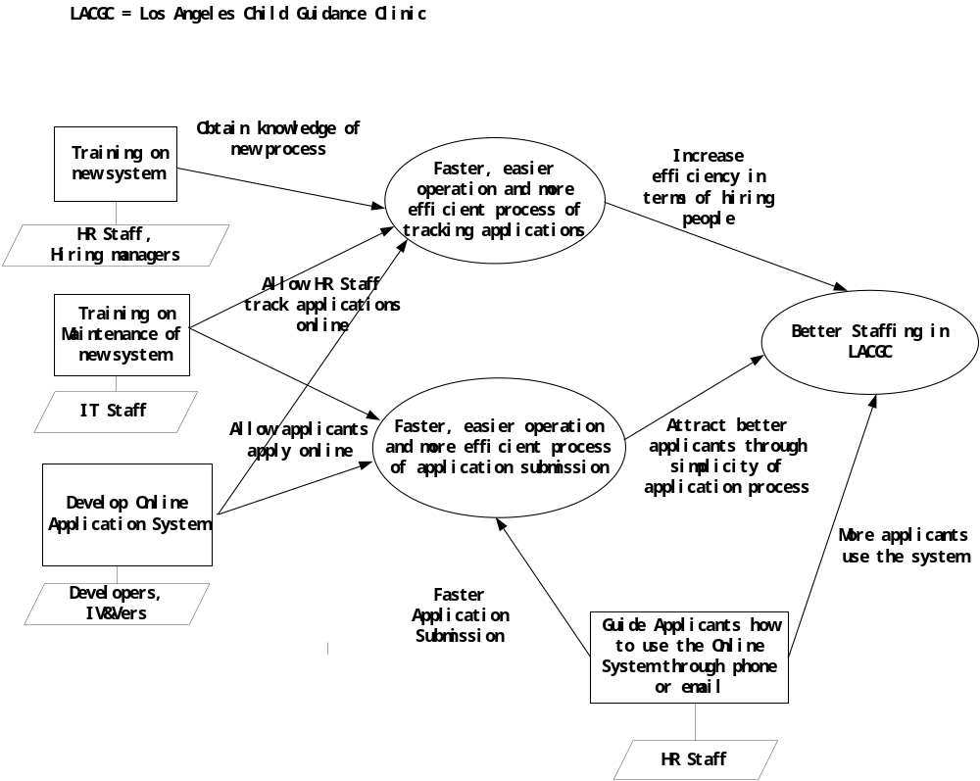
Figure 1: Benefits Chain Diagram of Online Application System

System Boundary and Environment

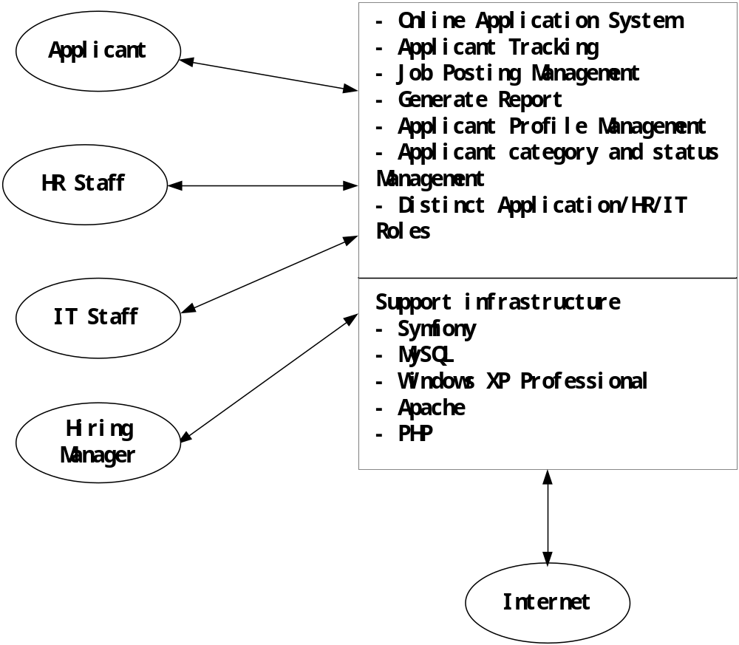
Figure 2: System Boundary and Environment Diagram of Online Application System

System Transformation

Information on Current System

Infrastructure

Hardware:
Terminal: PC
Database Server: pending for responses(not important)
Web Server: pending for responses (not important)
Software:
DBMS: MYSQL
Web Server : Apache/php web server
Server OS: Linux
Network: Internet
Programming Language: HTML, PHP,SQL
Terminal: Popular browser

Artifacts

Artifact | Description
Job Application Form | The form applicants use to apply a certain position
Descriptions of All Positions | The position description will be showed in the application process

Current Business Workflow
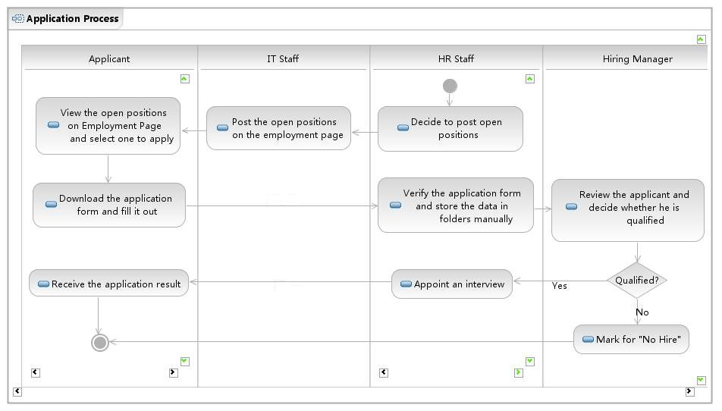
Figure 3. Current Business Workflow Diagram

System Objectives, Constraints and Priorities

Capability Goals
OC-1 Apply Jobs Online: The system allows applicants to apply to a position in Los Angeles Child Guidance Clinic through Internet.
OC-2 Track application online: The system allows HR Staff to track applicants.
OC-3 Automated Report Generation: The system is capable to generate reports from the data and export the reports into Microsoft Excel.
OC-4 Editable Job Posting: The system allows internal users to add, edit and remove Job Postings.
OC-5 Applicant Profile: The system allows applicants to maintain their own profiles.
OC-6 Data Storage: The system keeps historical data for about a year at least in the system before having to archive it .
OC-7 Attachments: The system allows applicants to add attachment when they apply positions.
OC-8 Security: The system protects applicants' confidential information such as SSN.

Level of Service Goals

Table 2: Level of Service Goals

Level of Service Goals | Priority Level | Referred SSRD requirements
System Availability | Must have | LOS - 1
System Query Time | Should have | LOS - 2
System Data Maintenance | Must have | LOS - 3

Organizational Goals

OG-1: Facilitate the Clinic's hiring process by using the online application system.
OG-2: Full staffing.
OG-3: Save the time of HR Staff so that they can spend more time on higher level tasks.
OG-4: Allow for more timely and better business decisions.
OG-5: Serve the maximum number of children in need.

Constraints
CO-1: Windows XP as an Operating System: The new system must be able to run on Windows platform.
CO-2: J2EE as a Development Framework: The new system must be developed by J2EE.
CO-3: SQL server 2005 as the database: The new system must use SQL Server 2005 for the database.
CO-4: Maximum budget is $5000/yr: The system must cost below $5000/yr.
CO-5: One year as delivery time: Time limit for delivery/installation is one year at max. Delivery is requested as soon as possible.

Relation to Current System
Table 3: Relation to Current System
Capabilities | Current System | New System
Roles and Responsibilities | Applicant: Submit application(s) by email or fax.  HR Staff: Receive applications email and fax and process them by using paper.  IT Staff: edit the posts for the  current system.  Hiring Manager: schedule the interview and make decision on whether to hire or not. | Applicant: Submit application(s) online and maintain profile.  HR Staff: Maintain the job posting, manage applications online, and generate report online.  IT Staff: Maintain the system.  Hiring Manager: Change status of applicants by using Online Application System.
User Interactions | Website employment page  Email  Fax | Web-based Application System
Infrastructure | OS: Windows XP | OS: Windows XP  Server: VMare3.5 as Virtual Server  DBMS: SQL Server 2005
Stakeholder Essentials and Amenities | NA | NA
Future Capabilities | NA | NA

Proposed New Operational Concept

Element Relationship Diagram
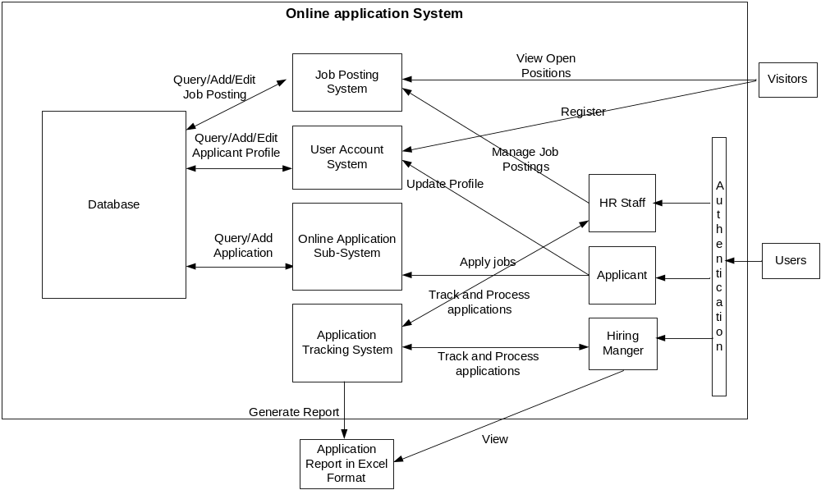
Figure 4: Element Relationship Diagram of Online Application System

Business Workflows

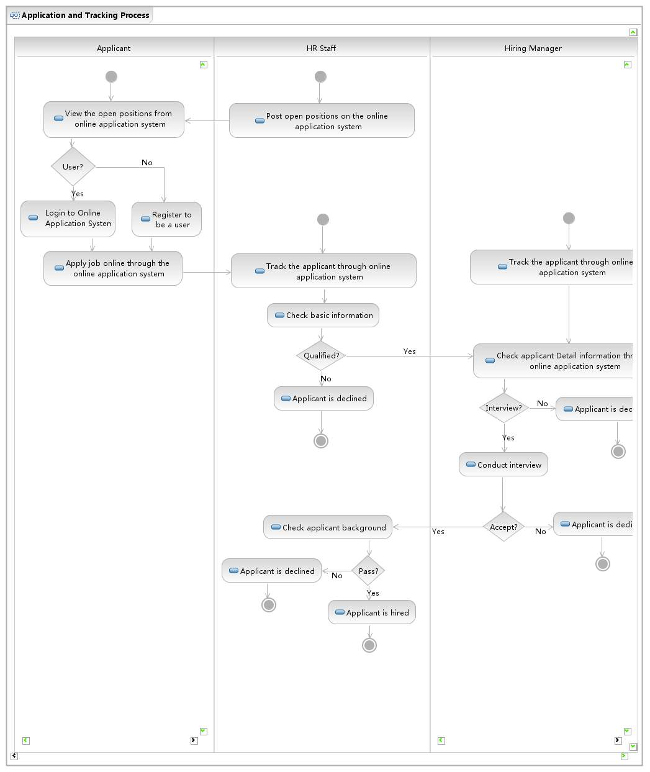
Figure 5. Business Workflow Diagram of Online application System

Organizational and Operational Implications

Organizational Transformations
- HR Staff must track applications online and maintain the job posting online.
- Applicants must create and update their profile information online.
- IT Staff must maintain the online application system.
- Hiring Manager must change the status of applicants.

Operational Transformations
- The option for new applicants to apply online instead of apply by paper, E-mail or Fax.
- The option for HR Staff to track applications online instead of track the applications by paper, E-mail and Fax.
- The HR Staff need to manage the job posting regularly by themselves instead of notifying IT Staff to do it.
- The option for HR Staff to generate application statistic report online.

